25.55: With the voltmeter connected across the terminals of the battery there is no current through the battery and the voltmeter reading is the battery emf; 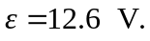
With a wire of resistance connected to the battery current flows and 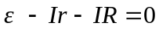
Call the resistance of the 20.0-m piece 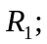 then the resistance of the 40.0-m piece is 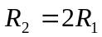.
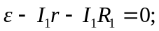
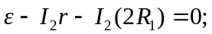
Solving these two equations in two unknowns gives 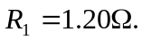 This is the resistance of 20.0 m, so the resistance of one meter is

